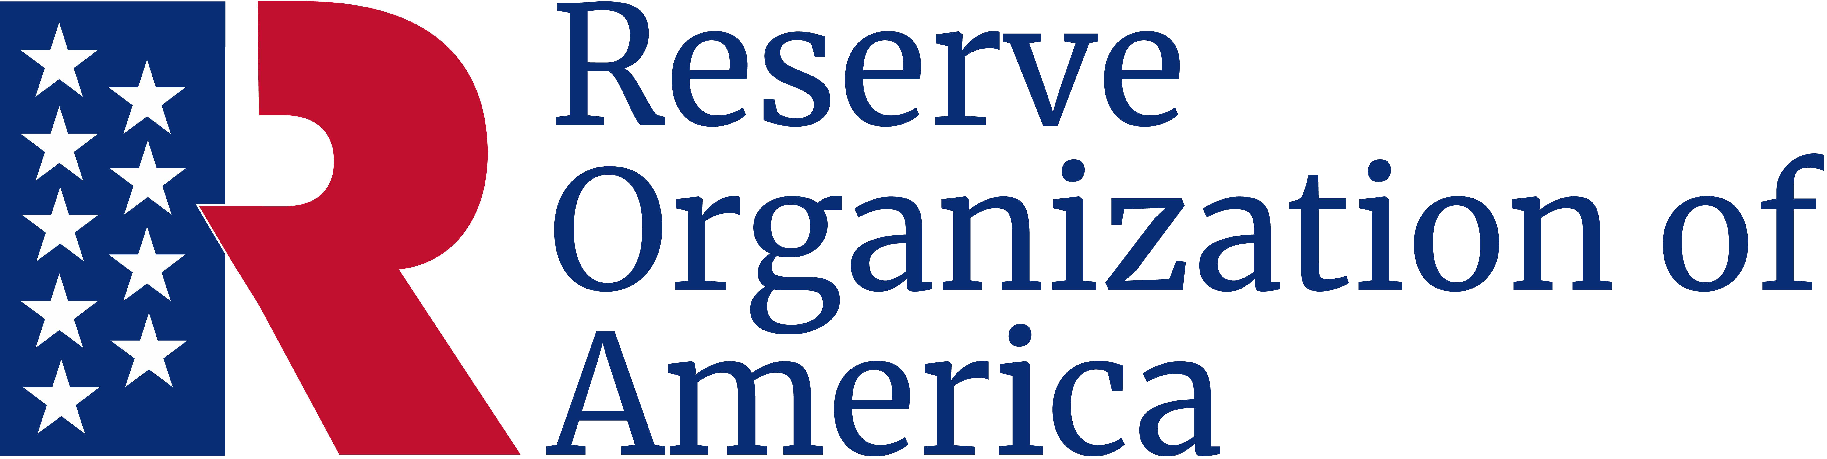

Outstanding Service

Award
John P. Jones
Major, USA (Ret.)
has served with distinction
commander of the
315th Aerospace Maintenance Wing
Somehwere AFB, Cityname, State
and has contributed significantly
to the National Defense of the United States
during the period
July 2015 through August 2019
and is presented this award in
recognition of outstanding service.

Sally B. Smith
Major General, USA (Ret.)
Department President
George Z. Pepper
Sergeant, USA (Ret.)
Department Secretary

