Reserve Organization of America

★ ★ ★
★ ★
★ ★ ★
★ ★
★ ★ ★
★ ★
★ ★ ★
★ ★
★ ★ ★
★ ★
★ ★ ★
★ ★
★ ★ ★
★ ★
★ ★ ★
★ ★

Chapter/Department Name
Presents this certificate to

Guest Speaker Name

Speaker rank, service, other title
In appreciation for being a guest speaker at the

Name of event

Location of event

Date of the event

Harvey M. Othername
Major General, USAR (Ret.)
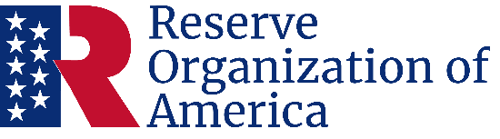
Department President
Francis A. Sinatra
Corporal, USAR
Department Secretary

