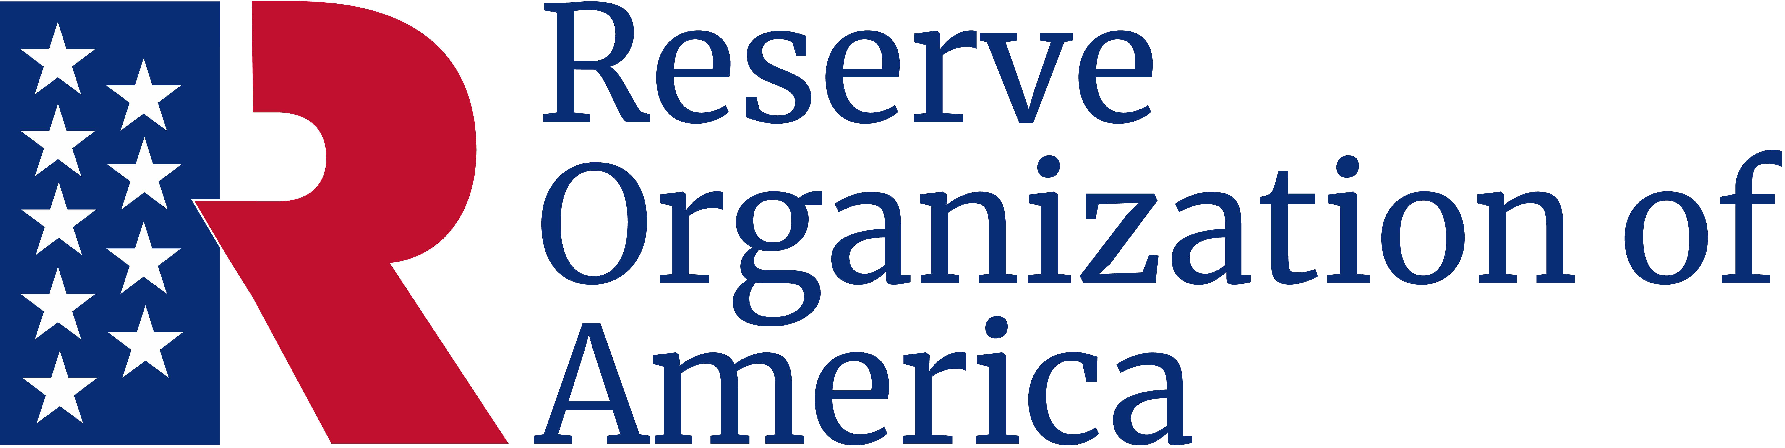

Outstanding Service

Award
This is to certify that
John P. Jones
Major, USA (Ret.)
has served with distinction the
name of department or chapter
as the
Vice President, 2024-2026
And is presented this Award in
recognition of outstanding service.

October 5, 2024

Sally B. Smith
Major General, USA (Ret.)
Department President
George Z. Pepper
Sergeant, USA (Ret.)
Department Secretary

