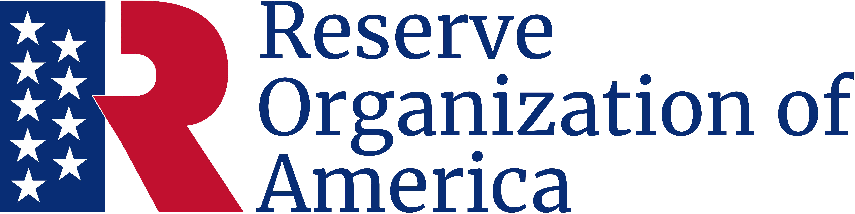

Nathan Hale Award
Be it known
Representative Daniel B. Oddbody
District 32, California
Has exhibited outstanding and dedicated service in the interest of National Security, and is recognized by the
Department of Name, Chapter Name
Of the Reserve Organization of America.
Given this day, October 5, 2024

Thomas T. Tannenbaum
Major General, USA (Ret.)
Department President
Charles C. Cookson
Chief Master Sergeant, USA (Ret.)
Department Secretary

