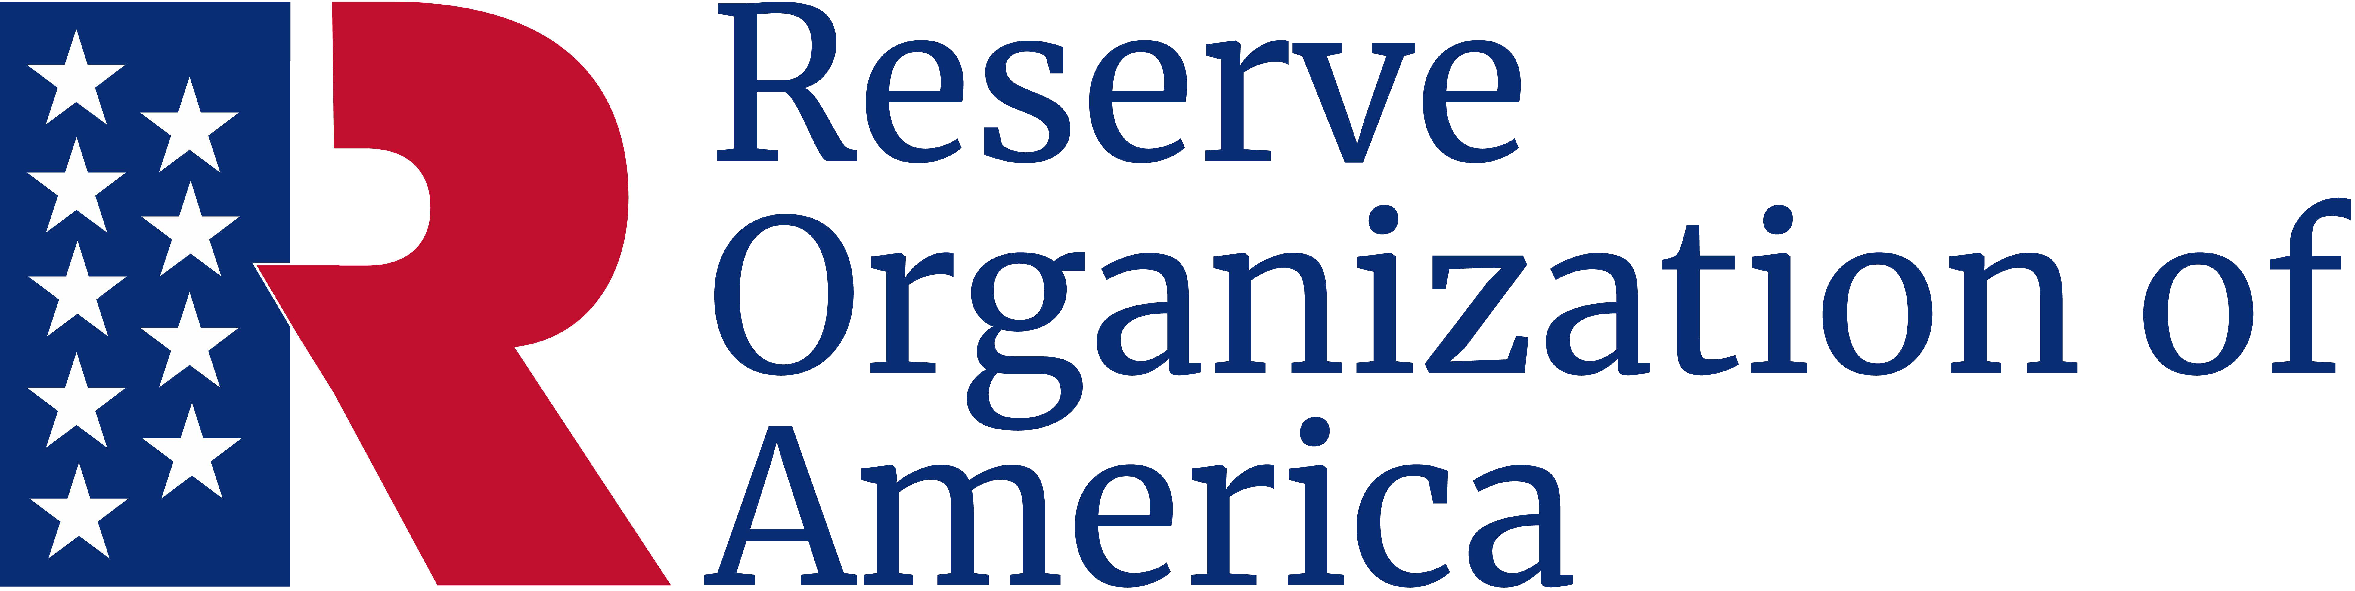

John Lynker ROA Department

Minute Man Award
Be it known
Frank F. Fernandez
Rank/Branch of Service/Title
Is presented this award in recognition of excellence in promoting public awareness of the value of the armed forces of the United States and in appreciation of service to ROA.
Presented
October 5, 2024

Thomas T. Tannenbaum
Major General, USA (Ret.)
Department President
Charles C. Cookson
Chief Master Sergeant, USA (Ret.)
Department Secretary

