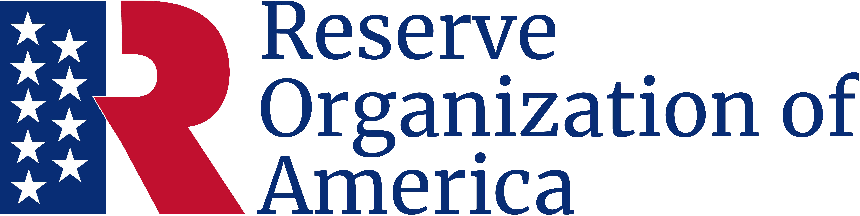

Longtimers Award
This is to certify that
Edward J. Manak
Major, USA (Ret.)
has been a loyal and dedicated member of this association for
53 Years
and is entitled to the respect and honor due to one whose loyalty and support have materially contributed to the achievement of ROA’s missions and programs.

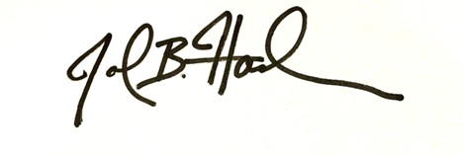
October 5, 2024

John B. Hashem
Major General, USA (Ret.)
Executive Director

