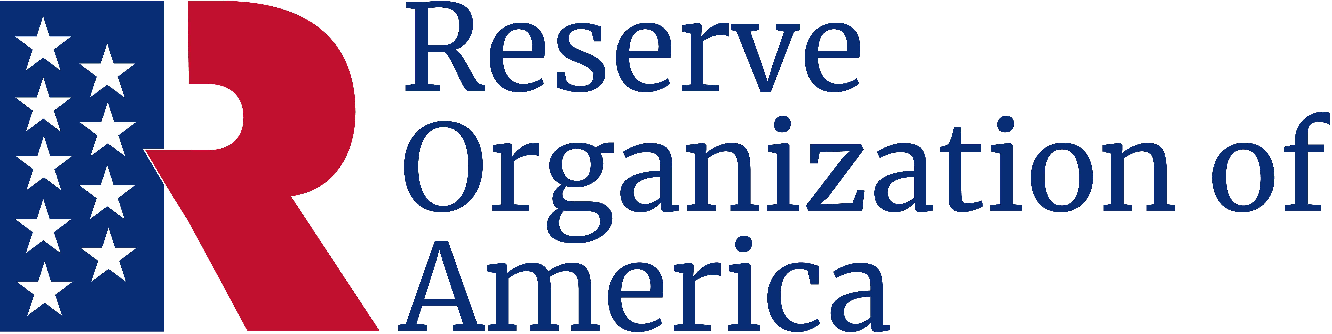

Family Support Award
Be it known
Frank F. Fernandez
Rank/Branch of Service/Title
Is presented this award in recognition of exceptional service
in support of military families.
Presented
October 5, 2024

Thomas T. Tannenbaum
Major General, USA (Ret.)
Department President
Charles C. Cookson
Chief Master Sergeant, USA (Ret.)
Department Secretary

