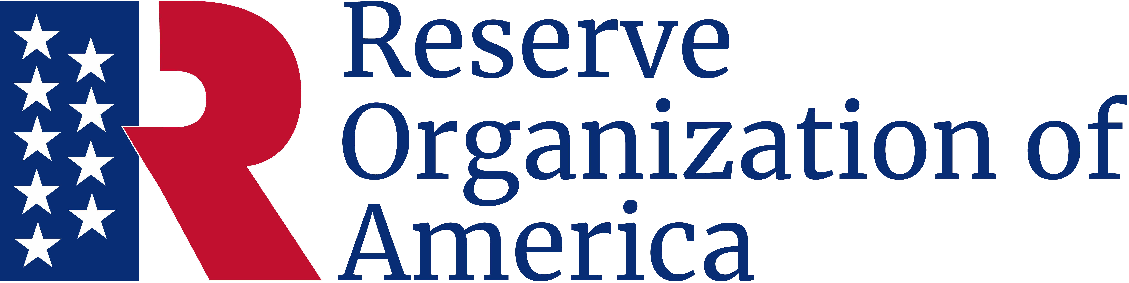

Certificate of Appreciation
Presented to
Peter P. Pettigrew
Major, USA (Ret.)
In appreciation for your support of
ROA’s mission and programs.

October 5, 2024

Thomas T. Tannenbaum
Major General, USA (Ret.)
Department President
Charles C. Cookson
Chief Master Sergeant, USA (Ret.)
Department Secretary

